
A Deep Learning-Based Approach for Food Quality Analysis Using Multi-Class Image Classification

Prepared by:
Ruqayya Mohammad Suleiman Al-Mashaqbeh: 2100908066
Hamza Yaman Riyadh Al-Aida: 2100908103

Supervisor:
Dr. Mohammed Samir Al-Aoun

Submitted in Partial Fulfillment of the Requirements for the Bachelor's Degree
in Data Science and Artificial Intelligence

Prince Al Hussein bin Abdullah Faculty of Information Technology
Al al Bayt University

Al Mafraq – Jordan
3/5/2026

Table of Contents
Acknowledgment 4
Declaration 5
Abstract 6
CHAPTER 1: INTRODUCTION 7
1.1 Introduction to Food Quality Analysis 7
1.2 Role of Machine and Deep Learning 7
1.3 Problem Statement 8
1.4 Study Objectives 8
CHAPTER 2: Related Work 9
2.1 Overview 9
2.2 Role of Deep Learning 10
2.3 Previous Works 10
2.4 Gaps 13
CHAPTER 3: Methodology 14
3.1 Image Acquisition 15
3.2 Data Preprocessing and Augmentation 16
3.2.1 Data Preprocessing 16
3.2.2 Data Augmentation 16
3.3 Building and Training CNN Models 18
3.3.1 Hyperparameters and optimization settings 19
3.3.2 Evaluation metrics 20
3.4 Development Environment and Libraries 21
CHAPTER 4: Results and Conclusion 22
4.1 Introduction to Results 22
4.2 Training Performance 22
4.2.1 Training Accuracy and Validation Accuracy 22
4.2.2 Training Loss and Validation Loss 22
4.3 Evaluation Metrics (Binary Classification) 23
4.3.1 Confusion Matrices 23
4.3.2 Accuracy 23
4.3.3 Precision, Recall and F1‑Score 23
4.3.4 Classification Reports 23
4.4 Evaluation Metrics (Threshold‑Agnostic) 23
4.4.1 ROC Curves and ROC‑AUC (Micro and Macro) 23
4.4.2 Precision Recall Curves and PR‑AUC (Micro and Macro) 24
4.5 Model Performance Comparison 24
4.6 Discussion of Results 25
4.6.1 Best Model 25
4.6.2 Cases of Underperformance 25
4.6.3 Challenges and solutions 25
4.6.4 Overfitting Risks and Mitigation 26
4.5 Conclusions 26
CHAPTER 5: Future works 27
5.1 Practical Project improvements 27
5.2 Research oriented improvements 28
Appendix: Data evaluation and visualization 29
Glossary 35
References 37

Acknowledgment

We extend our sincere thanks and deep appreciation to Dr. Mohammed Samir Al-Aounfor his continuous support throughout our graduation project and his constant dedication to providing guidance and advice. His clear approach in simplifying and explaining concepts had a significant impact on helping us understand various topics and overcome challenges.
We truly value his patience, dedication, and commitment to helping us achieve the best possible results. His support was a source of inspiration and encouragement throughout this journey.
We would also like to express our heartfelt gratitude to our families, friends, and everyone who offered us support and assistance during this important stage of our academic journey.

Declaration
We, Ruqaya Mohammed Sulaiman Al-Mashaqa and Hamza Yaman Riyad Al-Aida, hereby declare that the project entitled "A Deep Learning-Based Approach to Food Quality Analysis Using Multi-Category Image Classification," submitted as part of the requirements for the Bachelor of Science degree in Data Science and Artificial Intelligence, is our original work.
We confirm that all information, data, and sources used in this project have been properly documented and reviewed. We also acknowledge any contributions or assistance received from others during this project.
We further declare that this project has not been previously submitted for any other degree or examination at any other educational institution.
We take full responsibility for the content and accuracy of this project, and I understand that any false statement or omission of information may subject me to disciplinary action, including the cancellation of my degree.
Signed: Ruqaya Mohammed Sulaiman Al-Mashaqa, Hamza Yaman Riyad Al-Aida
Student ID: 2100908066, 2100908103

Abstract
This project aims to develop an artificial intelligence model based on deep learning techniques to analyze food quality using image data. The system allows the user to upload an image of a fruit or vegetable, and the model automatically performs the following tasks:
- Identifies the type of fruit or vegetable from a predefined set of categories.
- Determines whether the food is fresh or spoiled.
- Classifies the image into one of 28 categories representing different types of food and their conditions.
- If the food is classified as spoiled, the system alerts the user to the possibility that it is unfit for consumption. If it is fresh, the user is notified accordingly.
The model was trained using a high-quality, categorized dataset containing various types of fruits and vegetables in both fresh and spoiled states. This project represents a step towards intelligent food quality monitoring systems that contribute to reducing food waste, improving food safety, and supporting applications in agriculture, retail, and supply chain management.

CHAPTER 1: Introduction
With the rapid growth of the global population and the accompanying challenges particularly in the area of food security agriculture remains one of the key sectors facing immense pressure to provide sufficient food for human societies. One of the most critical challenges in agriculture is the issue of plant diseases, which significantly threaten both the quantity and quality of crop production. According to the Food and Agriculture Organization (FAO), plant pests and diseases are responsible for 20% to 40% of global crop losses annually [3]. These diseases can result in substantial economic losses due to reduced yields, increased management costs, and disruptions in food supply chains [1].
Plant diseases are generally caused by a variety of pathogens, including fungi, viruses, and bacteria. Their symptoms are usually visible on leaves, stems, fruits, or flowers, and can often be identified through human observation or by consulting agricultural specialists [3]. However, these traditional diagnostic methods while long standing are increasingly proving inadequate due to their susceptibility to human error, the need for expert knowledge, and the time and labor required [4]. Given the urgency of early and accurate detection to prevent widespread crop loss, reliance on manual techniques alone is no longer sufficient in meeting the rising global food demand.

1.1 Introduction to plant disease detection
In recent years, the world has witnessed tremendous technological advancements, especially in the fields of artificial intelligence, image processing, and machine learning. These developments have opened the door to innovative methods for monitoring plant growth and detecting agricultural diseases at early stages. Smart systems have emerged that monitor plants by capturing and analyzing images, relying on changes in leaf shape, color, and texture. This enables farmers and agricultural workers to conduct fast and accurate diagnoses of plant health.
****This project proposes designing a system based on machine learning techniques to analyze images of potato, tomato, and pepper leaves taken with regular cameras. The goal is to detect the presence of any diseases, identify the specific type, and suggest appropriate treatments based on a dynamic database. ****
To achieve high accuracy, the model is trained on a large number of labeled images of the mentioned plants' leaves. The importance of the project lies in providing smart and accessible technologies that help farmers make fast, accurate decisions regarding plant disease detection and control. The system aims to offer a low cost, easy to use solution accessible via a simple website.

1.2 Role of Machine and Deep Learning in Agriculture
The integration of machine learning (ML) and deep learning (DL) into agriculture has revolutionized traditional farming practices by enabling more precise, data driven decision making. As global food demands increase and environmental conditions grow more unpredictable, the need for intelligent agricultural systems has become essential. ML and DL techniques offer powerful tools to address challenges such as crop monitoring, yield prediction, soil management, pest control, and most notably, plant disease detection.
Machine learning is one of the most powerful modern tools for pattern recognition based on large volumes of structured data, including text, images, and more. These techniques are now being used effectively in agriculture to detect plant diseases early and with high precision, which positively impacts both the quantity and quality of agricultural production and helps reduce costs.
Machine learning allows plant diseases to be detected by analyzing visible symptoms such as leaf spots, shape distortions, and color changes. By training models on previously classified data, it becomes possible to distinguish between healthy and infected leaves and identify the type of disease and its recommended treatment.
Convolutional Neural Networks (CNNs) are among the most commonly used models for visual feature extraction. When trained on specific plant diseases, these networks can accurately recognize and differentiate between them.
Beyond detection, the role of these technologies extends to early intervention and resource optimization. By facilitating early diagnosis, ML and DL based systems help minimize crop losses, reduce dependency on chemical treatments, and support sustainable farming practices.
1.3 Problem Statement
Plant diseases remain a persistent threat to global agriculture, often resulting in substantial yield losses and reduced food quality. Traditional diagnostic approaches, such as manual inspection or expert consultation, are not only time consuming and labor intensive but also limited in scalability and accuracy. These limitations are especially problematic in regions lacking access to agricultural experts or diagnostic infrastructure.
Moreover, the early symptoms of many plant diseases can be subtle and easily misidentified, increasing the risk of delayed or incorrect treatment. This delay can lead to the rapid spread of infections, causing irreversible damage to crops and affecting the livelihoods of farmers.
Thus, there is an urgent need for technical solutions that leverage modern technology to quickly detect, classify, and suggest treatments for plant diseases with high accuracy and low cost.
1.4 Study Objectives
This study aims to build an intelligent model that helps farmers accurately identify and diagnose plant diseases, especially those affecting key vegetable crops such as peppers, potatoes, and tomatoes. The goal is to detect diseases early and provide appropriate treatment suggestions by analyzing images using machine learning.
A large dataset of classified images of various plant leaves will be collected to train the smart model. The model will be improved by expanding the dataset and performing further classifications in diverse environments and conditions.
With the increasing availability of mobile devices, affordable cameras, and computing power, there is a growing opportunity to develop automated, intelligent systems capable of detecting plant diseases quickly and accurately. However, there is still a gap in creating practical, low cost solutions that are accessible, easy to use, and robust across various plant species and disease types. This project addresses this gap by proposing a deep learning based multi class classification system for detecting diseases in crop leaves. The system aims to provide a scalable, image based diagnostic tool that supports farmers in making timely and informed decisions for disease management.
CHAPTER 2: Related Work
Plant diseases pose a serious threat to global food security, accounting for an estimated 20–40% annual crop yield loss worldwide. Early detection of plant diseases is crucial to enable timely intervention and reduce such losses [3]. Traditionally, identifying plant diseases relied on manual visual inspection by farmers or agronomists, looking for symptomatic signs (lesions, wilts, spots, etc.) on leaves, stems, or fruits. This conventional approach is labor intensive, subjective, and often error prone, as accuracy depends on the expert’s experience and may not scale to large farms. Moreover, many growers, especially in remote or resource limited regions, lack regular access to expert diagnosticians, leading to delays in disease identification. Plant disease detection has traditionally relied on expert visual inspection and laboratory tests. Farmers and plant pathologists identify symptoms on leaves, stems, or fruits to diagnose diseases, but this manual process is time consuming and can be subjective.
2.1 Overview of Plant Disease Detection Techniques
In the past few decades, automation of disease detection has been explored through imaging and machine learning techniques. Early computer vision approaches applied image processing pipelines: images of leaves were preprocessed, segmented to isolate lesions, and then hand crafted features (color, texture, shape descriptors) were extracted for use in a classifier. For example, Dubey and Jalal (2012) combined global color histograms, color coherence vectors, and Local Binary Patterns, using K means clustering to segment apple leaf spots; an SVM classifier on these features achieved about 93% accuracy in distinguishing three apple diseases. Similarly, Chai et al. (2010) analyzed tomato leaf spots using stepwise discriminant analysis on 18 color/texture features, attaining 94.7%–98.3% accuracy with different classifiers. Other traditional approaches include Bayesian classifiers, neural networks, and discriminant analysis on hand crafted features, reporting high accuracy on specific crops (e.g. 92.6% for five apple diseases, 97.2% for three rice diseases) [3], [7], [9]. These conventional methods demonstrated that automated image based disease recognition was feasible and often effective in controlled settings.
However, classical techniques have clear limitations. They typically require separate steps for image segmentation and feature extraction, which are labor intensive to design and often dataset specific. Performance can degrade if image conditions change (lighting, background, leaf orientation), since the features and thresholds are hand tuned for particular scenarios. Table 2.1 (later in this chapter) shows that early methods, while achieving high accuracy that involves complex feature engineering [1], [2], [6]. Moreover, classical methods generally struggled with large scale multi class problems and did not generalize well beyond the conditions under which they were developed.
To improve robustness and scalability, researchers have also experimented with advanced sensors and imaging beyond standard RGB photos. For instance, portable spectral sensors have been used to detect stress or disease by analyzing reflectance patterns: e.g. Mahlein et al. [4] employed hyperspectral imaging to distinguish healthy vs. diseased crop tissue, and other works used infrared or fluorescence imaging to detect subtle disease cues. While these sensor based approaches can improve early detection, they require specialized equipment and expertise, limiting their accessibility for everyday farming. Thus, the focus in recent years has shifted toward techniques that leverage machine learning and in particular, deep learning on regular images, which can be captured easily via digital cameras or smartphones. [5], [8]

2.2 Role of Deep Learning in Plant Disease Detection
The advent of deep learning, especially Convolutional Neural Networks (CNNs), has revolutionized plant disease detection in the last decade. Deep learning models automatically learn features directly from image data, eliminating the need for manual feature engineering. This end to end learning capability is well suited to the variability and complexity of plant disease symptoms. CNN based systems take raw leaf images as input and output disease class labels, internally learning the most relevant color and texture patterns for classification. This approach has proven to outperform earlier techniques. In some cases, even rival human expert performance.
Several factors enabled the rise of deep learning in agriculture: the availability of larger labeled image datasets, increases in computational power (GPUs), and improvements in CNN architectures and training frameworks. Modern CNNs can extract multilevel features (from edges and spots in early layers to complex lesion patterns in deeper layers) and are very robust when trained on sufficient data. For instance, Mohanty et al. demonstrated the feasibility of smartphone based disease diagnosis by training a deep CNN on a public dataset of 54,306 leaf images (PlantVillage). Their model learned to recognize 38 classes of diseased/healthy plant leaves and achieved 99.35% accuracy on held out test images [7]. This was a pivotal result, showing that a single CNN could handle many crops and diseases with near human accuracy.
Beyond classification, deep learning enables more complex tasks such as object detection and segmentation. CNN based detectors like Faster R-CNN, YOLO, and EfficientDet can detect multiple diseased regions in a single image, useful for analyzing complex field scenes. For example, YOLOv5 has been applied in real agricultural settings and shown to outperform traditional detectors in accuracy and speed [10]. Similarly, segmentation networks can delineate infected regions to estimate disease severity, making deep learning a flexible and scalable tool for automated plant disease diagnostics [9], [10].
2.3 Review of Prior Research and Datasets
Numerous research efforts have applied machine learning and deep learning to plant disease detection. Table 2.1 provides a comparison of selected prior models, illustrating the progression of this field in terms of models, data, and accuracy. Early deep learning studies focused on limited sets of diseases, often under controlled conditions, whereas later works expanded to more classes and more challenging image data. Alongside algorithm development, the compilation of large datasets has been crucial. The PlantVillage dataset, introduced by Hughes and Salathé [7], is a seminal contribution: it contains approximately 54,300 images covering 38 classes of plant disease (healthy and diseased leaves for 14 crop species) taken on uniform backgrounds. PlantVillage quickly became the benchmark for training and evaluating models – indeed, many studies in Table 2.1 used it either exclusively or in part. Models trained on PlantVillage have achieved extremely high accuracy (95–99% range) due to the dataset’s size and consistency. For instance, Mohanty et al. [7] and Ferentinos [11] both reported around 99% accuracy on PlantVillage, demonstrating the dataset’s suitability for supervised multi class image classification across 38 and 58 plant disease classes, respectively.
Datasets and prior studies have primarily focused on classification, for instance given of an image of a leaf, predict which disease (or healthy) it represents. Table 2.1 provides a comparison of selected deep learning models used for this purpose. Most studies framed the problem as multi class classification and achieved impressive results on focused and/or custom datasets. A common trend is the use of transfer learning with pretrained CNNs like AlexNet, VGG16, or ResNet50 for object detection pipelines. For example, Abade et al. (2020) tested several models including MobileNet and VGG16, achieving accuracies up to 99.6% [6]. Andrew et al. (2022) used DenseNet 121 on PlantVillage and achieved 99.81% accuracy [9], while Ferentinos (2018) explored multiple CNNs (e.g. AlexNet, GoogLeNet, VGG) across 58 plant disease classes with up to 99.53% performance [11]. These results highlight deep learning's ability to generalize over a wide range of diseases when trained on consistent, high quality image data.
When trained on large high quality datasets, it can detect plant diseases with high accuracy, especially at early stages of infection. The next section discusses the remaining gaps and challenges that these studies have identified.

Authors (Year) | Model Type | Dataset | No. of Classes | Highlights | Accuracy | Ref
Mustofa et al. (2023) | CNN, DCNN, YOLO, etc. | Custom datasets + PlantVillage | Varies by study | Compared 30+ deep learning models across various daatsets | YOLOv5: 90.8%  CNN, ResNet: 99.7%  DCNN: 99.74% | [2]
Singh et al. (2025) | CNN, CNN + Hybrid (GAN, RNN, SVM, RF) | PlantVillage, PlantDoc, Digipathos, NLB | Varies (Tomato, Potato, etc.) up to 171 | Comprehensive comparison of multiple datasets, DL accuracy comparisons | InceptionV3: 92.60%  PDICNet (custom CNN + ResNet50 + MRDOA): 99.73% | [3]
Bhagwat & Dandawate (2021) | ResNet50, VGG, etc. | PlantVillage, LifeCLEF, Tea leaf, etc. | Varies (up to 38+) | Comparative performance review under field and lab conditions | Lab - > CNNs: 99%  ML: 90%  Field -> VGG16 + C-DCGAN: 90%  ResNet50: 70% | [4]
Abade et al. (2020) | CNNs (MobileNet, AlexNet, VGG, GoogLeNet, InceptionV3, ResNet, DenseNet) | Multiple datasets (review of 121 studies) | Varies across studies | Systematic review of 121 studies focusing on CNN usage and architecture challenges | MobileNet: 99.6%, AlexNet: 95.75%, VGGNet: 98.08–99.49%, GoogLeNet: 87.00–99.55%, InceptionV3: 88.60–99.76%, ResNet: 99.59–99.75%, DenseNet: 99.72% | [6]
Mohanty et al. (2016) | CNN (GoogLeNet, AlexNet) | PlantVillage (controlled images) | 38 (26 diseases + 12 healthy) | Evaluated training against transfer learning using color, grayscale, and segmented image datasets | 85.53–99.34% | [7]
Balafas et al. (2023) | 18 CNN models (ResNet152, ShuffleNet…) | PlantVillage, PlantDoc | 38 (PlantVillage), 28 (PlantDoc) | Compared 18 classifiers and 5 detection models on clean vs real world datasets | 99% (PlantVillage), 61% (PlantDoc) | [8]
Andrew et al. (2022) | CNN (DenseNet 121, ResNet 50, TL) | PlantVillage (controlled images) | 38 (PlantVillage) | Developed real time mobile app for field level plant disease detection | 99.81% (DenseNet 121)  98.83% (ResNet 50) | [9]
Yao et al. (2023) | ML: SVM, KNN, LR  DL: ANN, CNN, AlexNet, GoogLeNet, ResNet… | PlantVillage, citrus, tomato, apple datasets | 4-5+ | Compared traditional ML vs DL methods; CNN generally outperformed shallow models | Varies  CNN: 98.12%, AlexNet: 95.75%, ANN: 92.94% | [10]
Ferentinos (2018) | CNN (AlexNet, VGG, GoogLeNet, etc.) | Extended PlantVillage (lab + field) | 58 | Compared performance on lab vs field images; Trained on lab and tested on field and viceversa | Lab only - > AlexNet: 99.06%, VGG: 99.53%, GoogleNet: 97.27%  Field -> VGG: 32.23%/66.69%, AlexNetOWTBn: 32.23%/62.57% | [11]
Table 2.1 – Comparison of Selected Plant Disease Detection Models from different related works (CNN = Convolutional Neural Network; TL = Transfer Learning; SVM = Support Vector Machine; RF = Random Forest; VGG = Visual Geometry Group)

2.4 Gaps in Existing Literature
Despite previous researchers showing and illustrating effective progress, there are several concerns and challenges that persists in the field of plant disease detection.
To begin with, a large proportion of studies use the PlantVillage dataset or similarly controlled images for training and testing. Models often perform poorly when applied to images from different sources or field conditions. This points to a need for diverse, annotated datasets captured in real farms under varying lighting, backgrounds, and occlusions. As Balafas et al. (2023) emphasize, generating larger open datasets from real world fields is crucial, since most current public datasets are limited or biased to lab settings. [8]
Secondly, almost all deep learning approaches focus on RGB image data alone, while ignoring other potentially informative data sources. For instance, thermal imaging, hyperspectral data, and environmental sensor information (e.g., temperature, humidity, and soil parameters) can provide complementary cues for more robust disease detection. However, the integration of such multi modal data remains an open challenge. Most current studies are limited to visual symptoms observed on leaves using RGB imagery, without incorporating additional sensor modalities or contextual field data.[1][3][8] This lack of fusion across data types restricts the generalizability and accuracy of disease prediction models, especially under complex real world conditions.[4]
Moreover, the vast majority of studies employ convolutional neural networks (CNNs) for plant disease classification, owing to their strong performance in spatial feature extraction. However, researchers have suggested that alternative or hybrid architectures could offer additional benefits. For instance, combining CNNs with recurrent neural networks (RNNs) may enable modeling of disease progression over time, while transformer based mechanisms could improve performance on large or complex plant imagery. [2][8]
When it comes to variability in lighting conditions such as shadows, glare, or overexposure and occlusions caused by overlapping leaves or fruits, it can significantly reduce the accuracy of models trained on clean, well centered images. This challenge remains largely open, as many datasets (e.g., PlantVillage) lack such variability. Some studies have attempted to address this by employing color constancy algorithms or using data augmentation to simulate various lighting conditions [3][4]. Nevertheless, these efforts are still limited, and further work is needed to ensure that deep learning models remain robust under real world conditions, where lighting and occlusion are common. [8]
Furthermore, Generative Adversarial Networks (GANs) have shown promise for data augmentation, particularly for addressing class imbalance and synthesizing rare diseased leaf patterns. [3][4][8] Despite their potential, these techniques remain underexplored in the current literature.
Ultimately, achieving high accuracy in plant disease classification often requires deep and complex models, which come with significant computational demands. This poses a major challenge for real time that will be used in agricultural fields. While some studies have demonstrated progress with efficient models and compatible architectures like MobileNet [6][9], the balance between accuracy and inference speed remains an ongoing concern. Mohanty et al. (2016) showed high accuracy using CNNs on PlantVillage images but acknowledged the importance of developing models’ diagnosis [7]

CHAPTER 3: Methodology
The proposed methodology consists of nine segments, from image acquisition, data preprocessing, and CNN model training. This is followed by model evaluation, model deployment, and API development. The final stages include user interface development, integration testing, and user testing and interaction. The goal is inserting a RGB leaf image and outputs a predicted class. This chapter mainly focuses on the first 3 segments.
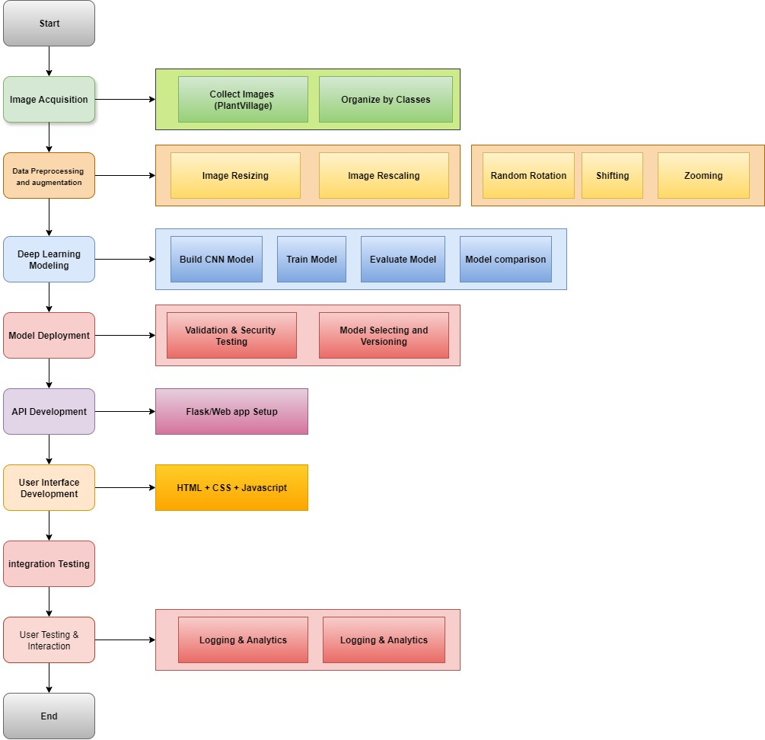
Figure 3.1 End-to-End Methodology workflow

3.1 Image Acquisition
The recommended dataset used for the project is called PlantVillage Dataset, and it is defined as a large dataset of diseased plant leaf images and corresponding labels, and it was created for use in plant disease detection systems, it generally consists of 54,303 healthy and unhealthy RGB leaf images divided into 38 categories by species and disease.
After image acquisition, the dataset is arranged in a folder-per-class layout to enable automatic label discovery by the data loaders. The notebook defines three roots: /dataset/train, /dataset/validation, and /dataset/test, within each class, and within each root creates one subdirectory per disease class.
The split policy is defined as follows: 80% training, 10% validation, 10% test per each class, each class has been stratified by pre-allocating counts. It is important to notify that the dataset counts were precomputed and stored in a Data Frame, and not dynamically split (train_test_split.)
Class | Train | Validation | Test | Total
Pepper__bell___healthy | 1182 | 148 | 148 | 1478
Pepper__bell___Bacterial_spot | 797 | 100 | 100 | 997
Potato___healthy | 121 | 16 | 15 | 152
Potato___Late_blight | 800 | 100 | 100 | 1000
Potato___Early_blight | 800 | 100 | 100 | 1000
Tomato_healthy | 1272 | 160 | 159 | 1591
Tomato_Leaf_Mold | 761 | 96 | 95 | 952
Tomato__Tomato_YellowLeaf__Curl_Virus | 2566 | 321 | 321 | 3208
Tomato_Bacterial_spot | 1701 | 213 | 213 | 2127
Tomato_Septoria_leaf_spot | 1416 | 178 | 177 | 1771
Tomato_Spider_mites_Two_spotted_spider_mite | 1340 | 168 | 168 | 1676
Tomato_Early_blight | 800 | 100 | 100 | 1000
Tomato__Target_Spot | 1123 | 141 | 140 | 1404
Tomato_Late_blight | 1527 | 191 | 191 | 1909
Tomato__Tomato_mosaic_virus | 298 | 38 | 37 | 373
Total | 16504 | 2070 | 2064 | 20638
Table 3.1: Dataset description for the proposed project, consisting of 15 classes of plant leaves, both healthy and diseased, that’s been divided into training, validation and testing subsets
This filesystem organization (referenced in the notebook via TRAIN_PATH, VALID_PATH, and TEST_PATH) lets the framework infer labels from directory names, and load batches without manual label files. It also simplifies auditing counts per class, prevents mislabeling, and keeps the exact same class set across train/validation/test.

3.2 Data Preprocessing and Augmentation

Data preprocessing and augmentation form critical steps in the methodology of plant disease detection using deep learning. Preprocessing ensures that raw images are cleaned, standardized, and made suitable for input into convolutional neural networks (CNNs). Data preprocessing and augmentation are both crucial for preparing image data for machine learning models, but they serve different purposes. Preprocessing focuses on making the data consistent and suitable for analysis, while augmentation aims to increase data diversity and potentially prevent overfitting by creating new, synthetic examples from existing data.

3.2.1 Data Preprocessing

Typical preprocessing operations include resizing images to a uniform dimension, normalization of pixel values, these steps reduce variability in image quality and help the model focus on meaningful disease related features rather than irrelevant artifacts.
The following list describes its preprocessing skills and its details:
- Data splitting: The split policy applies to Training, validation and testing (80% training, 10% validation, 10% testing), as it preserves an untouched test set for the final report.
- Image Resize: Although a raw image is 256 x 256 dimensions, we had to implement it on code for confirmation.
- Image Rescale: All input images were normalized by rescaling pixel values to the range [0, 1] using a factor of 1./255 for training, validation and testing datasets.
Preprocessing steps were applied uniformly to training, validation, and testing datasets and ensured all images were standardized to a fixed size and normalized pixel ranges, allowing models to learn effectively.

3.2.2 Data Augmentation
Augmentation was deliberately restricted to the training set, introducing variability (rotations, flips, shifts, zooms, color changes). This not only enhances the robustness of the trained model but also reduces the risk of overfitting, enabling the model to perform well on unseen validation and test images and enhance model generalization. The reason for not implementing augmentation on validation and testing (shuffle = false) is because we need to measure the real performance on true data, not on synthetic variants.
The following augmentation processes addresses the challenge of limited and imbalanced datasets by artificially increasing the diversity and quantity of training samples.
- Diversity: Augmentation enhances diversity by presenting leaves in multiple perspectives (rotation, shear, flips), the table below shows the exact augmentation techniques and their parameter values and the purpose they serve in improving the model.

Technique | Value/Parameter | Why?
Rescale | 1./255 | Normalize pixel values to [0,1] for stable and efficient model training. Such values would be too high for our model to process
Random Rotation | ±30° | Simulate natural variations in leaf orientation.
Width Shift | ±20% | Handle horizontal misalignments in image capture.
Height Shift | ±20% | Handle vertical misalignments in image capture.
Shear Transformation | 0.15 | Introduce slanting distortions to improve robustness to leaf angle changes.
Zoom | ±15% | Simulate different camera distances and crop variations.
Horizontal Flip | Enabled | Capture mirrored leaf orientations in the field.
Vertical Flip | Enabled | Simulate leaves photographed from opposite vertical directions.
Brightness Adjustment | Range = [0.8, 1.2] | Mimic lighting changes such as shade, sunlight, or camera exposure.
Channel Shift | 30 (pixel intensity shift) | Account for variations in color channels (lighting, soil background, camera sensors).
Fill Mode | "nearest" | Fill missing pixels after transformations to maintain image quality.
Table 3.2: Augmentation techniques and parameters
- Quantity: Data augmentation also increases the effective quantity of training samples through online augmentation. Using Keras’ ImageDataGenerator, techniques such as rotation, shifting, zooming, and flipping are applied dynamically when batches are fed to the model. This means that no new images are saved to disk, but the model encounters new variations of the same image in each training epoch. For example, with 797 training images in the Pepper_bell_Bacterial_spot class, training for 25 epochs could expose the model to as many as 797 × 25 = 19,925 unique augmented images. Thus, while the actual number of stored files remains 997, the model effectively experiences a dataset that is many times larger. This mechanism ensures that the model sees more unique samples over epochs and significantly enhances generalization, reducing the risk of overfitting to a small, fixed set of images.
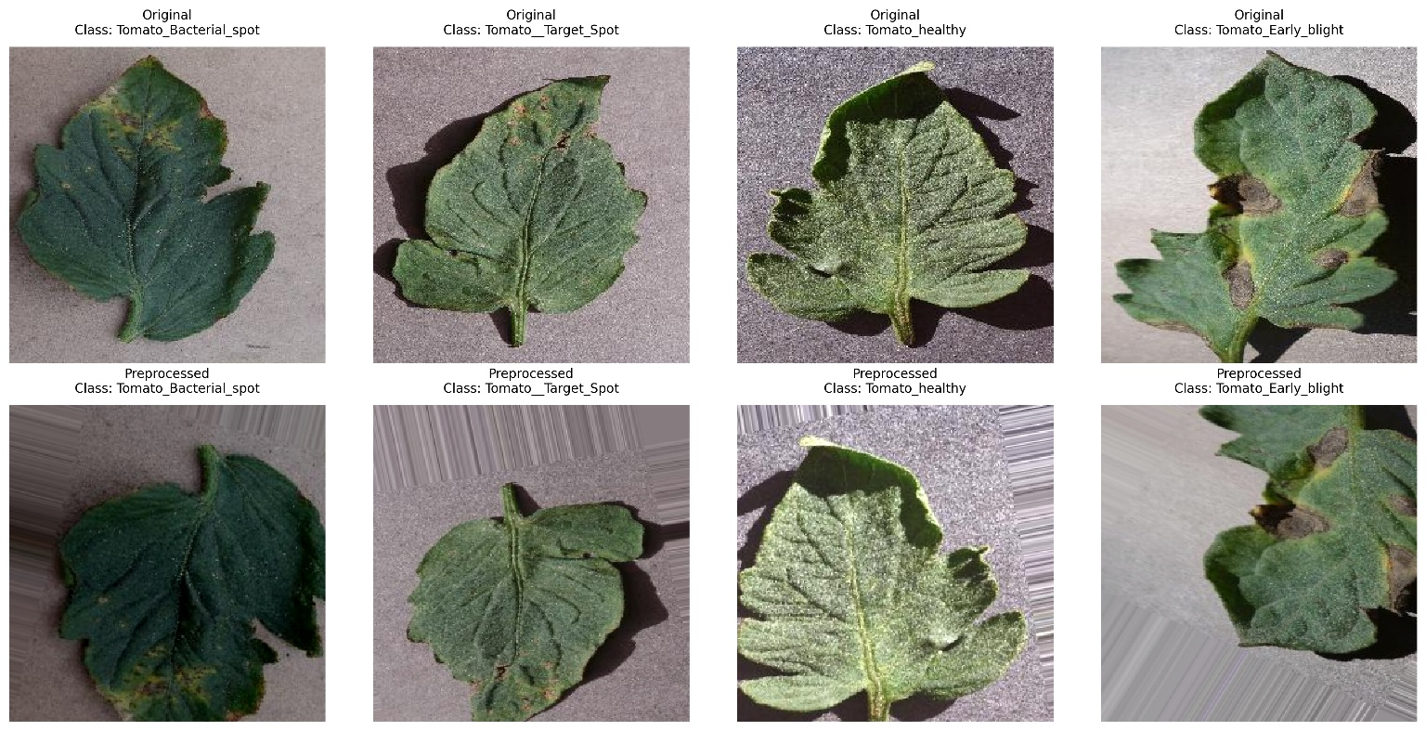
Figure 3.2: Examples of original and preprocessed tomato leaf images across different classes. Top row = original samples. Bottom row = Preprocessed and Augmented
These augmentation strategies ensure that the CNN models trained in this study could better recognize plant diseases under diverse real-world conditions, even with a relatively limited base dataset.

3.3 Building and Training CNN Models

Convolutional Neural Networks (CNNs) are widely used in computer vision tasks due to their ability to automatically extract hierarchical features from images, making them highly effective for plant disease detection. By tuning hyperparameters such as learning rate, batch size, number of epochs, and optimizer choice, CNN models like VGG16, ResNet50, and DenseNet121 can achieve high accuracy in classification tasks. Our primary use was using image classification over object detection because the primary goal is to identify the disease category of a leaf image rather than locating multiple diseased regions within a single image. This makes classification simpler, computationally less expensive, and more suitable for large scale agricultural applications where the input is usually a single leaf.
- ResNet50 (50 Layers): A deep convolutional neural network (CNN) with 50 layers, known for its residual learning architecture, which helps mitigate the vanishing gradient problem in very deep networks.
Key Feature and Components: Uses residual connections to train deep networks
How it works: Input images are first processed through convolutional layers to extract key visual features. Residual learning and skip connections are used to enhance deep feature learning and prevent issues like vanishing gradients. These extracted features are then passed through fully connected layers to classify the image into a specific disease category, enabling accurate and efficient diagnosis.
- VGG16 (16 Layers): A deep convolutional neural network (CNN) architecture known for its simplicity and effectiveness in image recognition and classification tasks (computationally heavy), outputs as a probability scores for multiple classes in multi-class classification.
Key Feature and Components: Simple architecture with sequential conv. layers
How it works: Input images first pass through convolutional layers that extract features such as edges and textures. Max pooling layers then reduce the spatial dimensions, improving the model’s robustness to input variations. The resulting feature maps are passed into fully connected layers for classification, and a softmax activation function outputs the final probability distribution across the 15 classes.
- DenseNet121 (121 layers): A convolutional neural network (CNN) architecture known for its dense connectivity pattern (4 dense blocks), where each layer receives input from all preceding layers. This differs from traditional CNNs where layers are typically connected sequentially for feature reuse.
Key Feature and Components: Dense connections and parameter efficiency compared to ResNet50.
How it works: Uses bottleneck layers to reduce the number of feature maps before applying a convolution, when you count all convolutional, pooling, and fully connected layers, the total adds up to 121 layers.
- Custom CNN: A convolutional neural network designed from scratch with a specific number of convolutional, pooling, and fully connected layers tailored to the task. Unlike pre-trained models like ResNet50 or VGG16, it is trained entirely on the dataset itself to allow full control over its architecture, depth, filter sizes, and activation functions, making it lightweight and flexible for specific plant disease detection tasks.
Key Feature and Components: 5 layers, dropout regularization, adaptive training and callbacks
How it works: Uses stacked convolutional and pooling layers to extract hierarchical features from input images. These features are flattened and passed through dense layers for classification using softmax activation.

- InceptionV3: A pre-trained convolutional neural network that is 48 layers deep, which is a version of the network already trained on more than a million images from the ImageNet database.
Key Feature and Components: Factorized convolutions, asymmetric convs, auxiliary classifiers, efficient grid reduction, label smoothing.
How it works: Takes the image input and processes it through a stem block of convolutions and pooling. Features are then learned using stacked Inception modules with parallel convolutions, factorization, and auxiliary classifiers. Finally, features are reduced, flattened, and classified with a dense layer and softmax activation.

- EfficientNetB0: Part of the baseline model of the EfficientNet family; A convolutional neural network designed by Google that strikes an optimal balance between accuracy and efficiency. It serves as the foundation for all other EfficientNet variants (B1–B7), which are scaled-up versions of this architecture.
Key Feature and Components: Compound scaling, MBConv blocks with squeeze-and-excitation modules, and a stem–head structure for efficient and accurate image classification.
How it works: First, it processes input images by first transforming them via the stem. The data then traverses a series of MBConv blocks, where features are efficiently extracted and refined using depthwise convolutions and SE attention. Finally, the head summarizes the features via pooling and classifies them using a dense layer with softmax activation.
3.3.1 Hyperparameters and optimization settings
The performance of deep learning models is strongly influenced by the choice of hyperparameters and optimization strategies. These parameters displays how the network learns from data, balances convergence speed with stability, and mitigates the risk of overfitting. In this study, careful attention was given to selecting appropriate values for learning rate, optimizer, batch size, number of epochs, and regularization techniques. Additionally, adaptive mechanisms such as learning rate scheduling and early stopping were incorporated to ensure efficient training. Transfer learning models were fine-tuned with specific layer freezing strategies, while a custom CNN was trained from scratch, each requiring tailored optimization settings.
The following subsections detail the configuration of these hyperparameters and the rationale behind their selection:
- Optimization & Schedulers: All models were trained with the Adam optimizer. Initial learning rates were 1e-4 for ResNet50, VGG16, inceptionv3 and EfficientNetB0, and 1e-3 for DenseNet121 and the custom CNN. We applied Callbacks: ReduceLROnPlateau (monitoring validation loss; factor 0.5; patience 5–8; min_lr=1e-7) and EarlyStopping (monitoring validation accuracy; patience 10–15; restore_best_weights=True) to adapt learning dynamics and prevent overfitting.
- Batching & Epochs: Training used batch size 32 for 25 epochs maximum, with EarlyStopping typically halting before the limit.
- Dropout: Used at rates around 0.3–0.5 in fully connected layers to reduce overfitting.
- Regularization: We used data augmentation on the training set and Dropout (0.3–0.5) in the classifier head.
- Transfer Learning & Fine-Tuning Strategy: For ResNet50, VGG16, inceptionv3 and EfficientNetB0, early convolutional layers were kept frozen, while later layers were unfrozen and updated. For DenseNet121, the convolutional base was frozen and only the classifier head was trained, leveraging pretrained features without fine-tuning the backbone. A custom CNN was also trained from scratch to provide a non-pretrained baseline.

3.3.2 Evaluation metrics
For evaluating the rate of the models, evaluation metrics is used to compare models, validate effectiveness, and ensure robustness before deployment. This is to ensure that not only CNN’s performances depend on architecture and dataset, but also on optimization choices. Although we considered to use learning rate tuning, we simply focused on performance metrics.
Binary Classification metrics are based on binary (1, 0) predictions. They are useful for selecting a prediction threshold by comparing score tradeoffs resulting from various thresholds.
The following binary classification metrics describes their meaning and equations:
- Confusion Matrix: Often considered as the foundation for many binary classification metrics. It is the threshold of dependent metrics that visualizes and summarizes the performance of a classification algorithm by tracking the model’s correct and incorrect positive and negative predictions (true positives, false negatives, true positives and false positives).

- Accuracy: It measures how many observations, both positive and negative, were correctly classified. It is calculated as the number of all correct predictions divided by the total number of the dataset.

$$Accuracy=\frac{TP+FN}{TP+FN+FP+TN}$$

- Precision: It shows the proportion of cases found that were actually relevant. It is calculated as the number of correct positive predictions divided by the total number of positive predictions.
$$Precision=\frac{TP}{TP+FP}$$

- Recall: Can also be called Sensitivity, it shows proportions of all relevant cases that were found, it is calculated as the number of correct positive predictions divided by the total number of positives (P = TP + FN$$Recall \left(Sensitivity\right)=\frac{TP}{TP+FN}$$

- F1-Score: Used only when you want seek a balance between precision and recall by fairly dealing with False positive and False negative.

$$F1-Score=2 *\frac{Precision *Recall}{Precision+Recall}$$

Threshold-agnostic metrics are based on predicted probabilities. They are useful for describing the strength of model signal across all thresholds and for selecting algorithms, features and hyperparameters.
The following threshold-agnostic metrics describes their meaning and details below:
- ROC-AUC: Stands for Receiver Operating Characteristics curve; and it is an evaluation measure that visualizes the performance of a binary classification model at various threshold settings, gives a global view of separability between diseased vs. healthy leaves. It is based on two basic evaluation measures:
- Recall (Sensitivity): $Recall (Sensitivity)=\frac{TP}{TP+FN}$
- False positive Rate: $FPR=\frac{FP}{FP+TN}$

- PR-AUC: Which is Precision-Recall area under the curve; and it is a metric used to evaluate the performance of binary classification models, particularly when dealing with imbalanced datasets. It summarizes the trade-off between precision and recall across various thresholds. A higher PR AUC value indicates better model performance, especially in distinguishing between the classes. It is based on both precision (y-axis) and recall (x-axis) respectively.
While confusion-matrix-based metrics provide insight at a fixed threshold, threshold-agnostic metrics (ROC-AUC, PR-AUC) gives a more comprehensive evaluation across all decision thresholds, ensuring robust assessment of the models.
3.4 Development Environment and Libraries
This project was developed using Python within a Jupyter Notebook environment (.ipynb). Python was selected for its extensive ecosystem of libraries supporting machine learning, deep learning, and image processing. The following libraries were utilized, each serving a specific role in the pipeline:
- TensorFlow / Keras: Primary framework for image preprocessing and augmentation tasks, building, training, and evaluating deep learning models (VGG16, ResNet50, DenseNet121, InceptionV3, EfficientNetB0, and Custom CNN).
- scikit-learn (sklearn): Used for evaluation metrics such as accuracy, precision, recall, F1-score, ROC-AUC, and PR-AUC.
- NumPy: Fundamental package for numerical computations, array manipulation, and handling of image data.
- Pandas: Data handling and tabular result storage (e.g., recording evaluation scores of models).
- Matplotlib & Seaborn: Visualization of training/validation accuracy and loss curves, ROC and PR curves, bar charts and heatmaps for metric comparison.
- OpenCV (cv2): Basic image handling: reading, resizing, and color conversion.
- os / glob: Directory management and loading image file paths.

Please note that the models were trained and tested using a GPU-enabled environment (Kaggle), which significantly reduced training times for large CNN architectures.

CHAPTER 4: Results and Conclusion

4.1 Introduction to Results
This chapter summarizes the experimental results obtained from training and evaluating several convolutional neural network (CNN) models on the plant disease detection dataset. The goal is to identify diseases on leaves accurately using deep learning. We evaluated multiple architectures, including models like ResNet50, VGG16, DenseNet121, InceptionV3, EfficientNetB0 and a custom CNN. Each model was trained with data augmentation and hyperparameters (dropout, early stopping, and learning‑rate schedules) to minimize overfitting. The following sections present training behavior, evaluation metrics and comparative performance, followed by a discussion of the best and worst performing models and the main conclusions.
4.2 Training Performance
4.2.1 Training Accuracy and Validation Accuracy
To evaluate the performance of the proposed models, both training and validation accuracy were monitored across epochs. Figures below shows the corresponding validation accuracy for all models considered (ResNet50, VGG16, DenseNet121, InceptionV3, EfficientNetB0, and the Custom CNN).
Training and validation accuracy were monitored throughout learning for each model. Overall, the transfer‑learning architectures grew rapidly, typically achieving over 90% accuracy on the validation set within the first 10–15 epochs. The curves showed smooth increases, with VGG16, DenseNet121 and the custom CNN reaching the highest accuracies. ResNet50 lagged behind the other models and its validation accuracy plateaued at a lower level, indicating that it struggled to generalize to unseen images.
Both training and validation accuracy results highlight clear differences in model performance. VGG16 and InceptionV3 achieved the strongest results, DenseNet121 and the Custom CNN also showed reliable performance in both metrics. In contrast, ResNet50 converged more slowly in training with unstable validation accuracy, while EfficientNetB0 performed poorly overall, indicating significant difficulty in learning and generalizing effectively. Overall, the results indicate that VGG16 provided the most balanced and robust performance, excelling in both training and validation. DenseNet121, InceptionV3, and the Custom CNN also showed reliable results, whereas ResNet50 and EfficientNetB0 underperformed in this experimental setup.
4.2.2 Training Loss and Validation Loss
Training and validation losses decreased steadily during training for all models. Early stopping prevented overfitting by halting training once the validation loss stopped improving. The learning‑rate scheduler reduced the learning rate when the validation loss plateaued, facilitating finer weight updates. Models such as VGG16 and DenseNet121 showed a smooth convergence of training and validation loss, whereas ResNet50 exhibited a larger gap between training and validation loss, again hinting at overfitting.

4.3 Evaluation Metrics (Binary Classification)
4.3.1 Confusion Matrices
Confusion matrices were generated for each model to illustrate how well the models distinguished among the various disease classes. The diagonals contained the counts of correctly classified samples, while off‑diagonal elements represented misclassifications. VGG16, DenseNet121, InceptionV3 and custom CNN produced confusion matrices with strong diagonal dominance, meaning most images were correctly classified. In contrast, ResNet50 and EffieicntNetb0 misclassified a higher number of samples, particularly confusing visually similar diseases such as early blight and late blight and mosiac virus.
4.3.2 Accuracy
On the test data, VGG16 achieved the highest accuracy, confirming its strong generalization ability. InceptionV3 and DenseNet121 followed closely, demonstrating robust performance across classes. The Custom CNN also delivered competitive results, validating its effectiveness despite being a simpler architecture. In contrast, ResNet50 showed lower accuracy, indicating weaker performance compared to other transfer learning models. EfficientNetB0 performed the worst, struggling to reach the accuracy levels achieved by the other networks.
4.3.3 Precision, Recall and F1‑Score
Weighted averages across all classes were computed. VGG16 and DenseNet121 attained very high precision and recall, resulting in F1‑scores around. The custom CNN also performed well along with precision and recall. InceptionV3 and EfficientNetB0 were slightly lower but still robust, while ResNet50 recorded the lowest precision and recall values, reflecting its difficulty in correctly predicting certain diseases.
4.3.4 Classification Reports
Detailed classification reports were generated for each model, listing per‑class precision, recall and F1‑score. These reports confirmed that VGG16, DenseNet121 and the custom CNN consistently achieved F1‑scores above 0.98 for almost all disease classes. Slightly lower scores were observed for classes with fewer training samples, but the drop was negligible. ResNet50 displayed more variability, with some classes (e.g., bacterial spot) achieving decent F1‑scores while others (e.g., early potato blight) lagged behind.
4.4 Evaluation Metrics (Threshold‑Agnostic)
4.4.1 ROC Curves and ROC‑AUC (Micro and Macro)
Receiver Operating Characteristic (ROC) curves plot the true positive rate against the false positive rate across different classification thresholds. The Area Under the Curve (ROC‑AUC) quantifies the separability of the classes. Micro‑average ROC‑AUC considers all classes jointly, whereas macro‑average ROC‑AUC averages the AUC of each class. The results indicate that VGG16 achieved the strongest ROC-AUC values, with both micro and macro averages exceeding, confirming its excellent sensitivity and specificity balance. DenseNet121 and InceptionV3 also performed very well, closely following VGG16. The Custom CNN delivered competitive results, showing its capability in distinguishing between positive and negative cases despite being a lighter architecture. In contrast, ResNet50 recorded slightly weaker ROC-AUC values, while EfficientNetB0 exhibited the lowest performance, consistent with its lower accuracy results.
4.4.2 Precision Recall Curves and PR‑AUC (Micro and Macro)
The results show that VGG16 once again delivered the strongest performance, with micro and macro PR-AUC scores above 0.99, reflecting its ability to maintain high precision without sacrificing recall. DenseNet121 and InceptionV3 also performed strongly, demonstrating robust balance across classes. The Custom CNN achieved competitive results, further validating its effectiveness. On the other hand, ResNet50 yielded lower PR-AUC scores, while EfficientNetB0 showed the weakest performance, indicating difficulties in handling positive class predictions effectively.
4.5 Model Performance Comparison
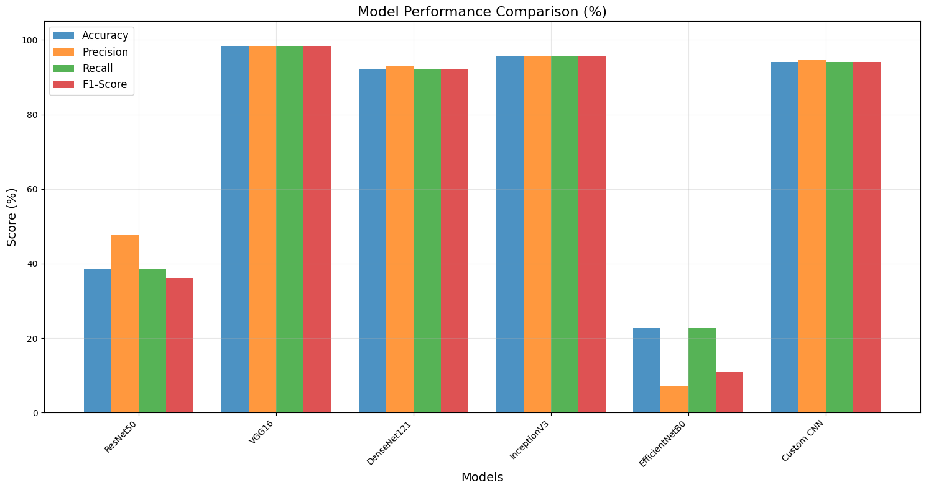
Figure 4.1: Model Performance comparison on Bar Chart
Model | Accuracy (%) | Precision (%) | Recall (%) | F1-Score (%)
ResNet50 | 38.67 | 47.62 | 38.67 | 36.06
VGG16 | 98.44 | 98.47 | 98.44 | 98.44
DenseNet121 | 92.29 | 92.91 | 92.29 | 92.20
InceptionV3 | 95.75 | 95.81 | 95.75 | 95.73
EfficientNetB0 | 22.66 | 7.17 | 22.66 | 10.80
Custom CNN | 94.09 | 94.58 | 94.09 | 94.15
Table 4.1: Model Performance comparison for transfer learning CNN models, along with Custom CNN

The table summarizes the performance of all evaluated models in terms of accuracy, precision, recall, and F1-score. VGG16 achieved the best overall performance, with nearly perfect results across all four metrics (≈ 98%), demonstrating excellent reliability and balance between precision and recall. InceptionV3, DenseNet121, and the Custom CNN also performed strongly, with accuracies above 92% and F1-scores above 92%, indicating robust classification capability. In contrast, ResNet50 showed weaker performance (accuracy ≈ 39%, F1-score ≈ 36%), reflecting poor generalization. EfficientNetB0 performed the worst, with very low accuracy (≈ 23%) and an F1-score of only ≈ 11%, highlighting significant difficulty in classifying plant diseases effectively.
4.6 Discussion of Results
4.6.1 Best Model
Among all evaluated models, VGG16 consistently delivered the best overall performance. It attained the highest accuracy and F1‑score and achieved near‑perfect ROC‑AUC and PR‑AUC values. DenseNet121 and the custom CNN were close behind, offering comparable accuracy and robustness. The success of these models can be attributed to their architectures; VGG16 and DenseNet121 provide rich callbacks through their deep convolutional layers, and fine‑tuning allowed the network to adapt to the specific patterns of plant diseases.
4.6.2 Cases of Underperformance
ResNet50 and EfficientNetB0 was the weakest performer in this study. Its accuracy, F1‑score and PR‑AUC were significantly lower than those of the other models. The model often confused classes with similar visual features, resulting in a higher number of false positives and false negatives. This underperformance might be due to the smaller number of trainable layers used during fine‑tuning or the model’s sensitivity to training hyperparameters.
4.6.3 Challenges and solutions
Despite achieving high performance across multiple deep learning models, several challenges emerged during the development and evaluation process. Issues such as data imbalance, potential overfitting, limited dataset diversity, and computational demands affected model reliability and generalization. To address these challenges, a combination of preprocessing, augmentation, transfer learning, and optimization strategies were employed. The following list summarize the challenges encountered and the solutions implemented.
- Data Imbalance: Some disease classes contained far more samples than others, causing biased learning where majority classes were favored.
Solution: Data augmentation (rotations, flips, zoom, brightness and channel shifts) was used to artificially expand minority classes. Batch shuffling further reduced imbalance effects.
- Risk of Overfitting: High-capacity models (e.g., VGG16, DenseNet121, InceptionV3) rapidly reached very high training accuracy, risking memorization of dataset-specific features.
Solution: Dropout layers, early stopping, and model checkpointing were used, while careful tuning of learning rates and optimizers (Adam at 1e-3 or 1e-4) improved generalization.
- Limited Dataset Diversity: PlantVillage-like datasets are collected under controlled conditions and do not fully represent field variability (lighting, backgrounds, occlusion).
Solution: Extensive on-the-fly augmentation simulated real-world conditions, and transfer learning from ImageNet-pretrained models improved robustness to unseen variations.
- Computational Complexity: Deep models such as DenseNet121 and InceptionV3 required high GPU resources and long training times.
Solution: A lighter Custom CNN was implemented, offering competitive accuracy with reduced computational cost. Adjustments to batch size and adaptive optimization also improved efficiency.
- Evaluation Limitations: Accuracy alone is insufficient in imbalanced data, potentially overestimating performance.
Solution: Threshold-agnostic metrics (ROC-AUC and PR-AUC, both micro and macro) were included, providing a clearer picture of sensitivity, precision-recall balance, and class-level discrimination.

4.6.4 Overfitting Risks and Mitigation
Although the models achieved very high evaluation scores, including PR-AUC values close to 1.0, there remains a risk of overfitting. This arises mainly from the nature of the dataset: many of the images, such as those from PlantVillage, are “clean lab images” with uniform backgrounds, controlled lighting, and minimal noise. Under such conditions, deep models like ResNet50, DenseNet121, InceptionV3, and EfficientNet may inadvertently “cheat” by memorizing background textures, lighting patterns, or color distributions rather than focusing on the disease-related features of the leaves. As a result, performance on validation and test data may appear excellent, but generalization to real-world farm environments with noisy, occluded, or overlapping leaves could be limited.
Several measures were taken to reduce this risk. Data preprocessing and augmentation (rotation, flipping, brightness variation, channel shifting, etc.) were applied to introduce diversity and prevent the models from memorizing fixed patterns. Hyperparameter tuning (learning rate, batch size, optimizer selection) further improved model generalization, while the use of multiple architectures (VGG16, DenseNet121, InceptionV3, ResNet50, EfficientNetB0, and a Custom CNN) ensured that performance was not dependent on a single biased model.
Despite these efforts, further improvements can still be made. Future work could incorporate cross-validation to better assess model robustness across different splits of the data. Additionally, the inclusion of field-collected images would improve dataset diversity and reduce the lab-to-field gap. Advanced regularization techniques, such as increased Dropout or L2 weight decay, could also provide stronger safeguards against memorization. Finally, applying transfer learning with fine-tuning on noisy, real-world datasets would help the models adapt more effectively to practical agricultural conditions. More is discussed in CHAPTER 5

4.5 Conclusions
This study demonstrated that deep convolutional neural networks can achieve very high accuracy in the automatic detection of plant diseases from leaf images. Transfer-learning models, particularly VGG16 and DenseNet121, outperformed both the baseline ResNet50 and the custom CNN. The best models achieved near-perfect precision–recall and ROC-AUC values, underscoring their ability to distinguish healthy leaves from various diseases reliably. However, the lower performance of ResNet50 and EfficientNetB0 highlighted the importance of selecting the right architecture and fine tuning strategy. Limitations include the potential for overfitting and the reliance on clean laboratory images; future work should evaluate the models on field images with more noise and lighting variability. Additional data augmentation techniques or domain adaptation methods may further improve generalization.
CHAPTER 5: Future works
While this study encompasses a systematic evaluation of using deep learning models using multi class classification, there are numerous options available for future developments for both practical project and research oriented improvements. Figure 5.1 illustrates practical project workflow stating the following diagrams.
5.1 Practical Project improvements
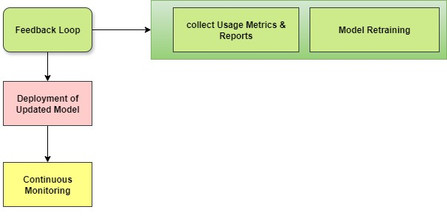

Figure 5.1: Practical project improvement. Feedback loop is initially implemented through collecting usage metrics and reports and model retraining. The updated model is then deployed and subjected to continuous monitoring to enhance the performance and reliability of the plant disease detection system.
- Feedback loop: The cycle continues as the model outputs are compared with real world results and user actions to generate new data that retrains and improves the model over time. Feedbacking serves as a continuous improvement mechanism that ensures the model remains accurate and reliable after deployment.
  - Collecting Usage Metrics & Reports: Data Science and Artificial intelligence generally involves collecting metrics such as model performance (accuracy, precision), business value (KPIs, ROI), data quality, and operation efficiency. And then using these results to generate reports that convert complex data into understandable formats like charts and graphs to convey performance and insights.
  - Model retraining and Iterative processes: Every model needs to be retrained in some way. Many researchers [5] stated that it maintains accuracy overtime, where models are periodically refined with new data from real world environments to address evolving conditions. Iterative processes such as k-fold cross-validation and other deep learning architectures and transfer learning models should be considered as a good approach when new disease samples or environmental variations are available, ensuring adaptation of the system to unseen conditions.

- Deployment of updated model: After continuous training and testing and showing satisfying performance and results, we can confidently deploy the updated model pipeline to its service. On the other hand, there is, however, a risk of the updated model performing poorer than the previous model even after retraining. Continuous monitoring explains its details.
- Continuous monitoring: Continuous monitoring of model performance is crucial to catch performance degradation, data drift, and concept drift in real time. Monitoring involves placing the old model for a period of time or until it has served a particular number of requests. The new model is then served the same data to generate predictions. This allows comparison of both model’s predictions to determine which is performing better. It also involves implementing real time monitoring for model prediction latency and error rates. Setting up alerts for significant anomalies helps ensure prompt response.

5.2 Research oriented improvements
Research oriented improvements demonstrates and suggests options that aims to address fundamental limitations and expand the scientific and technical capabilities of the proposed system to achieve greater adaptability to real-world conditions, and long-term scalability in agricultural applications.
- Advancements in Dataset Quality & Diversity: Data science advancements are tackling dataset quality and diversity through automated data cleansing and validation, data augmentation, synthetic data generation, and the integration of multiple, diverse data sources to improve model fairness and generalization. Expanding datasets to include rare diseases, early-stage symptoms, and mixed infections, along with data augmentation techniques, coupled with synthetic image generation (e.g., GANs) can further improve diagnostic accuracy.

- Integration of Multimodal Data (beyond RGB): Most current plant disease detection systems rely solely on RGB images, which can limit detection accuracy under environmental conditions. Using multimodal inputs such as hyperspectral imaging, thermal imagery, and metadata (e.g., humidity, temperature) can provide complementary information to enhance feature extraction and classification performance. Merging these data sources at the feature or decision level is a promising research direction for improving real-world resilience of plant disease detection systems [4].

- Backend Integration with Mobile Applications: The backend infrastructure serves multiple purposes, including managing model hosting, handling requests from mobile clients, collecting new field data for the feedback loop, and distributing updated model versions.

Integrating the plant disease detection model with a mobile application enables real time, user friendly access for farmers and agricultural workers. This integration can be implemented using frameworks such as Flutter/Dart, which offers cross-platform support, or Kivy with Buildozer for Python based deployment, which also requires Windows Subsystem for Linux (WSL) for building Android packages.

Later then, a lightweight deep learning architecture MobileNet is installed, trained and sustained due to their low computational requirements and competitive accuracy, making them ideal for mobile hardware devices.[6]

- Integrating Deep Learning and Classical Machine Learning Algorithms: While CNNs excel at automated feature extraction from large-scale datasets, traditional models like SVM, Random Forest, or KNN can provide lightweight, interpretable, and computationally efficient classification. By leveraging CNNs for feature extraction and classical ML for decision making, researchers can achieve higher robustness, especially in resource-constrained environments or when training data is limited.

By combining traditional ML models (e.g. decision trees, random forests…etc) with deep learning’s neural networks, researchers and organizations can achieve more precise AI powered data analytics [1][9][10]. This is especially useful in predictive modelling for agriculture industries, particularly in plant disease detection.
Appendix: Data Evaluation and Visualization
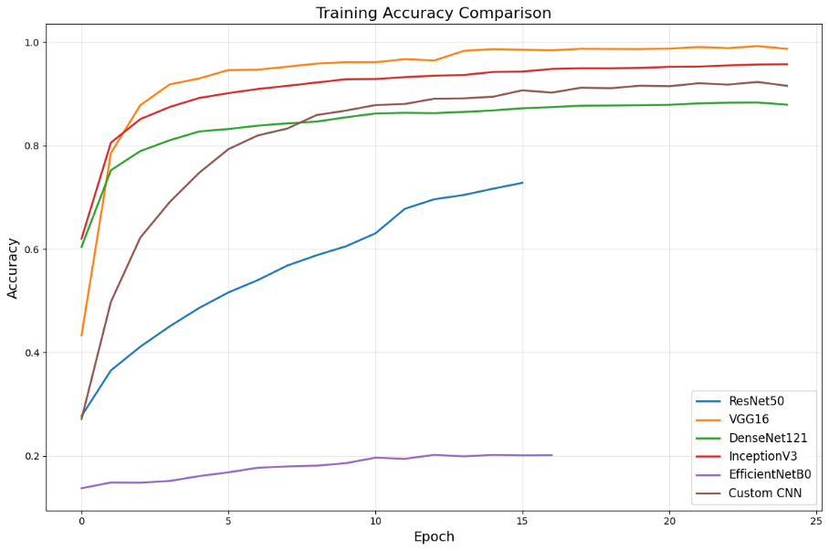
Figure A.1 Training Accuracy comparison

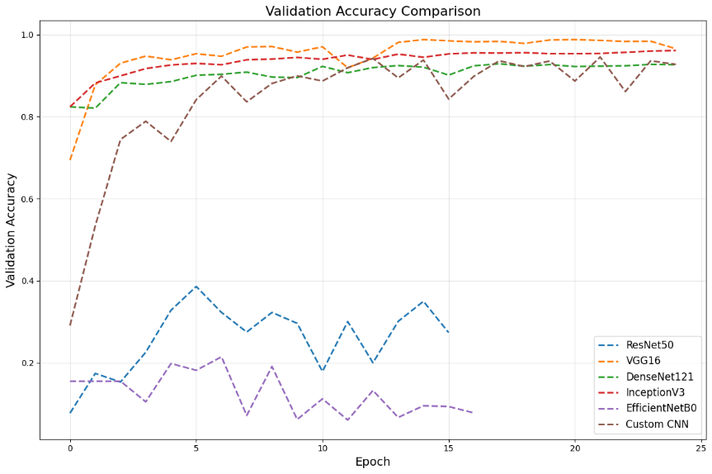
Figure A.2 Validation Accuracy comparison
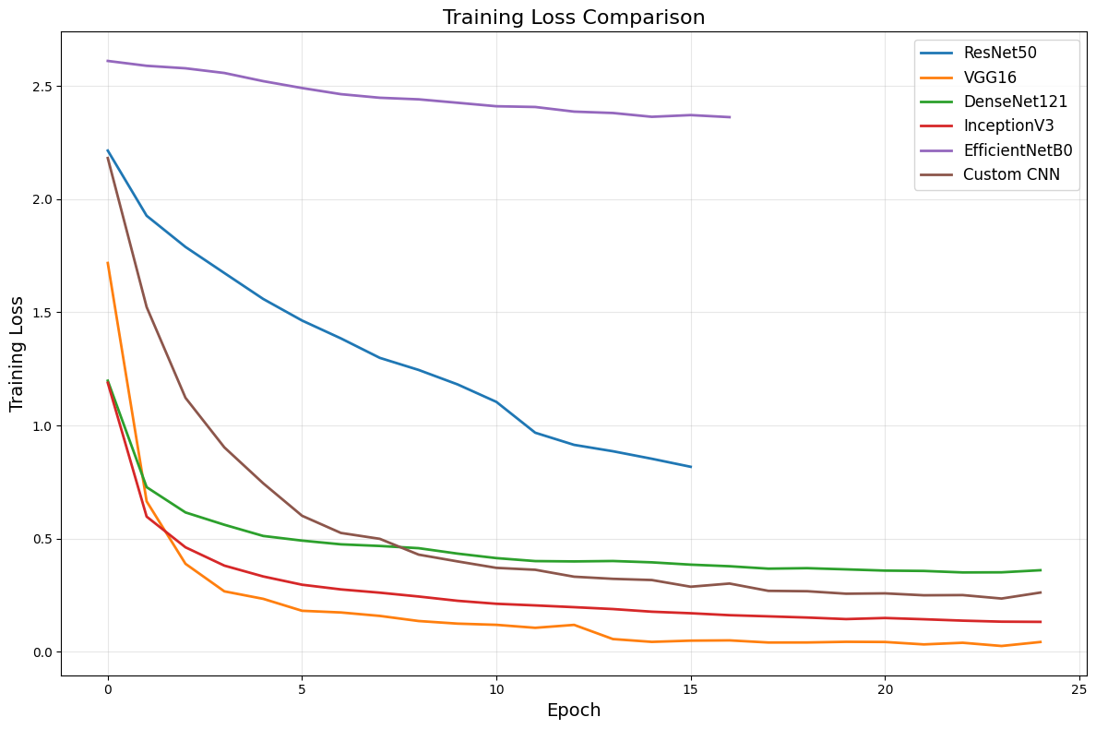

Figure A.3 Training Loss Comparison
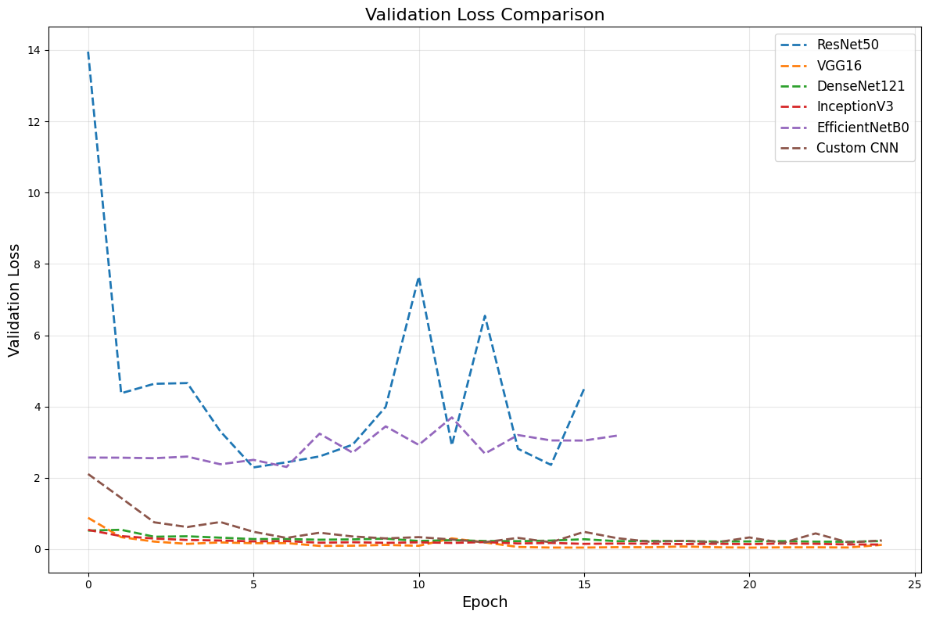
Figure A.4 Validation Loss Comparison
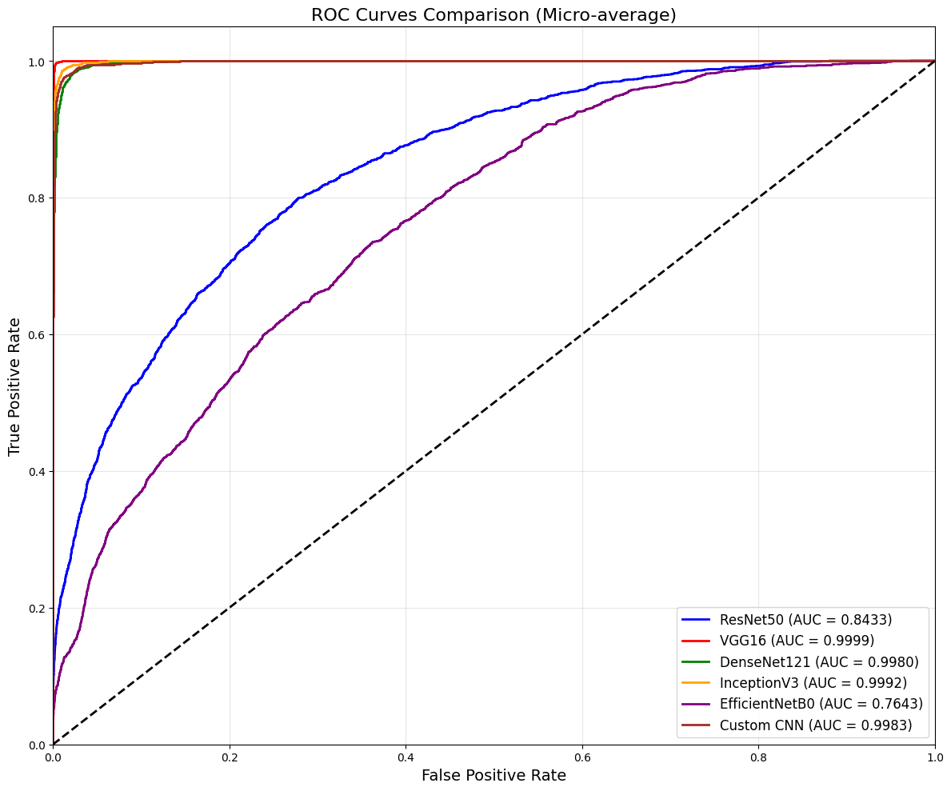
Figure A.5 ROC Curves Comparison
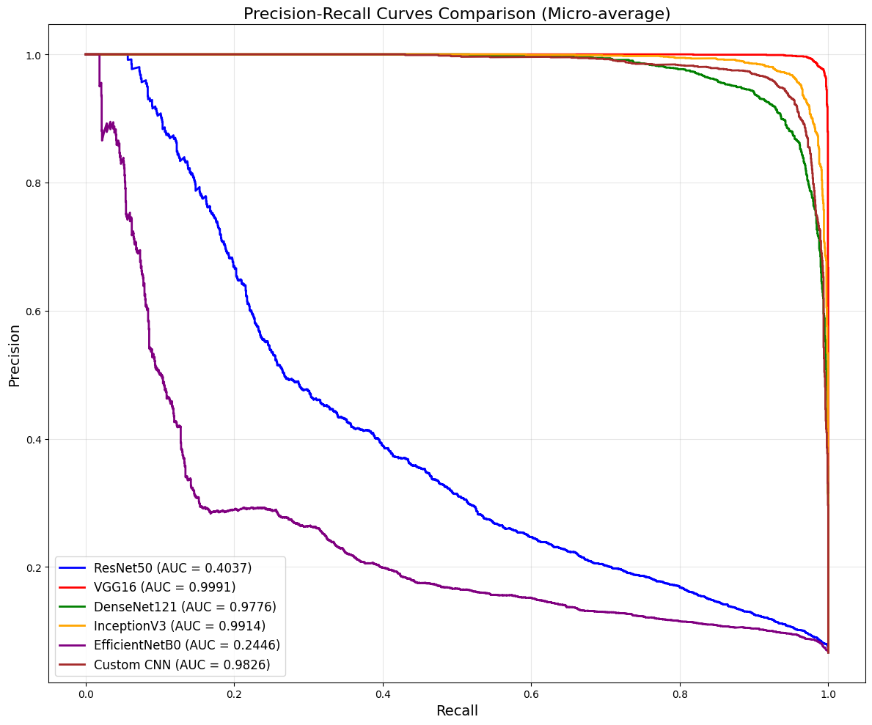
Figure A.6 PR Curves Comparison
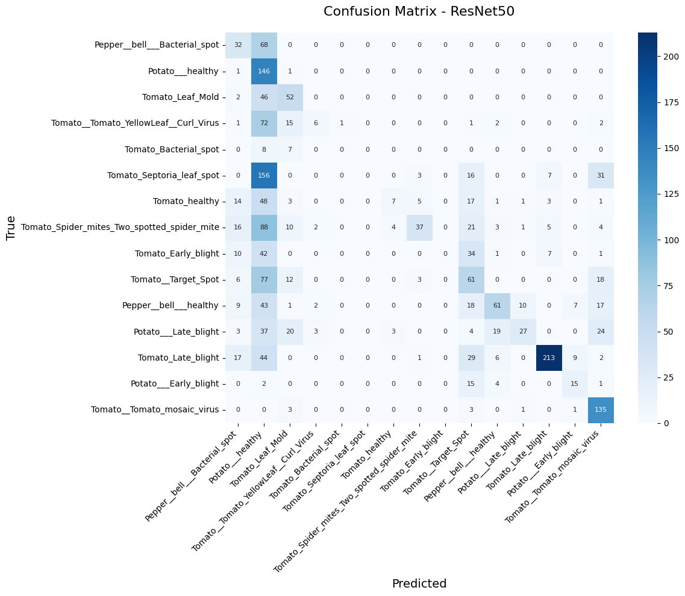
Figure A.7 Confusion Matrix Heatmap for ResNet50
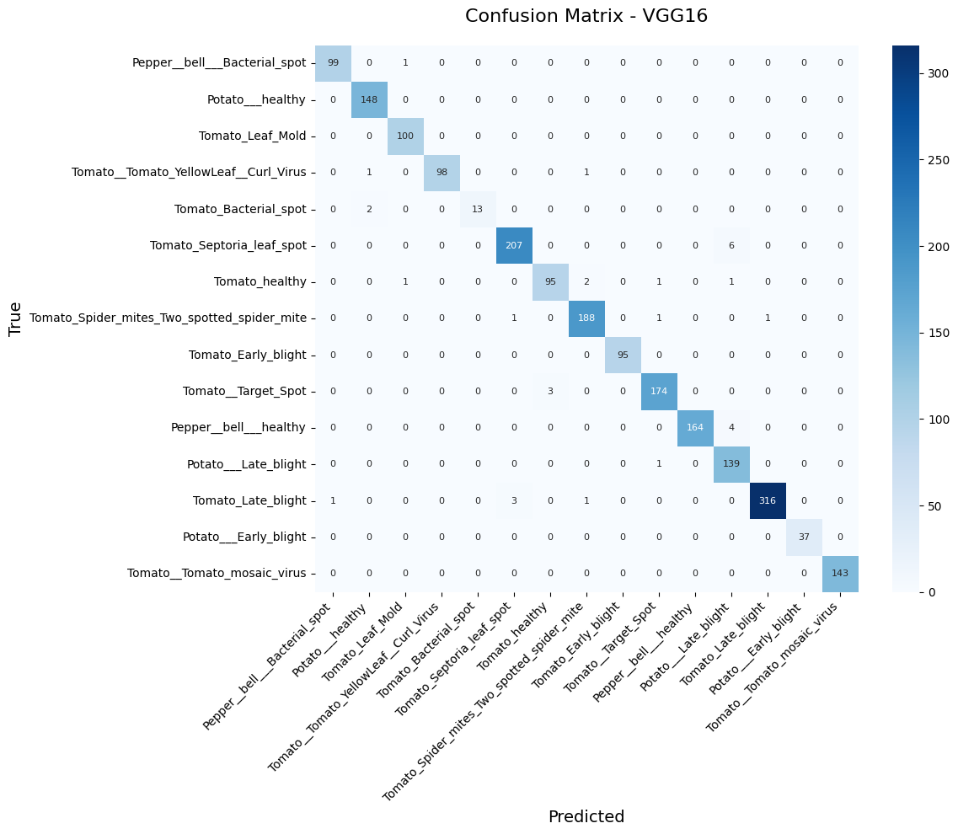
Figure A.8 Confusion Matrix Heatmap for VGG16
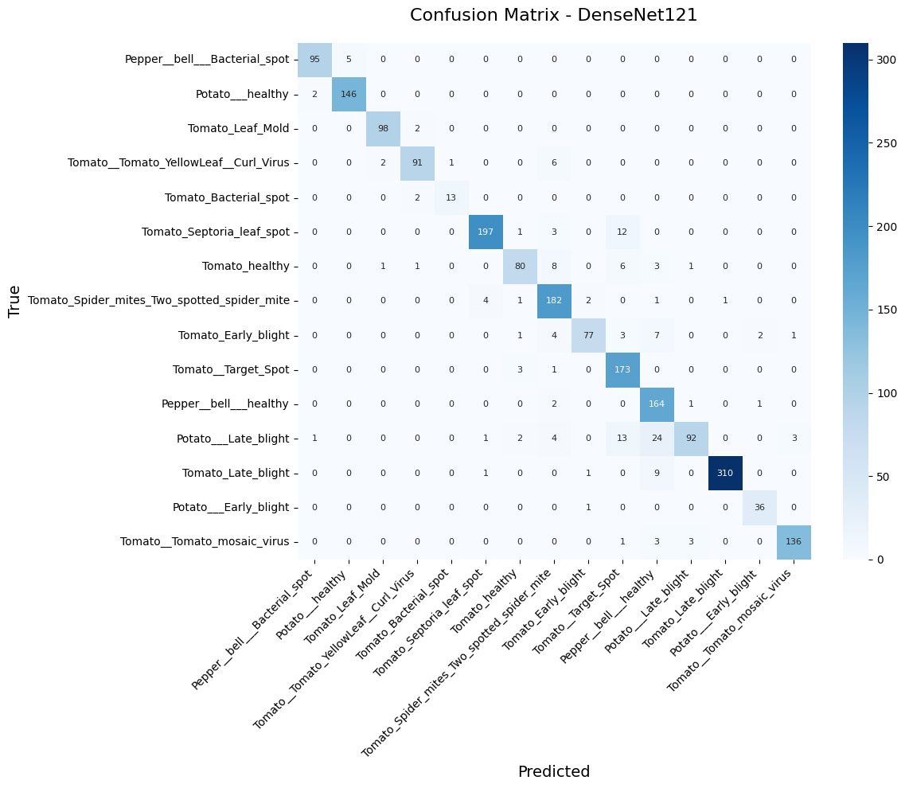
Figure A.9 Confusion Matrix Heatmap for DenseNet121
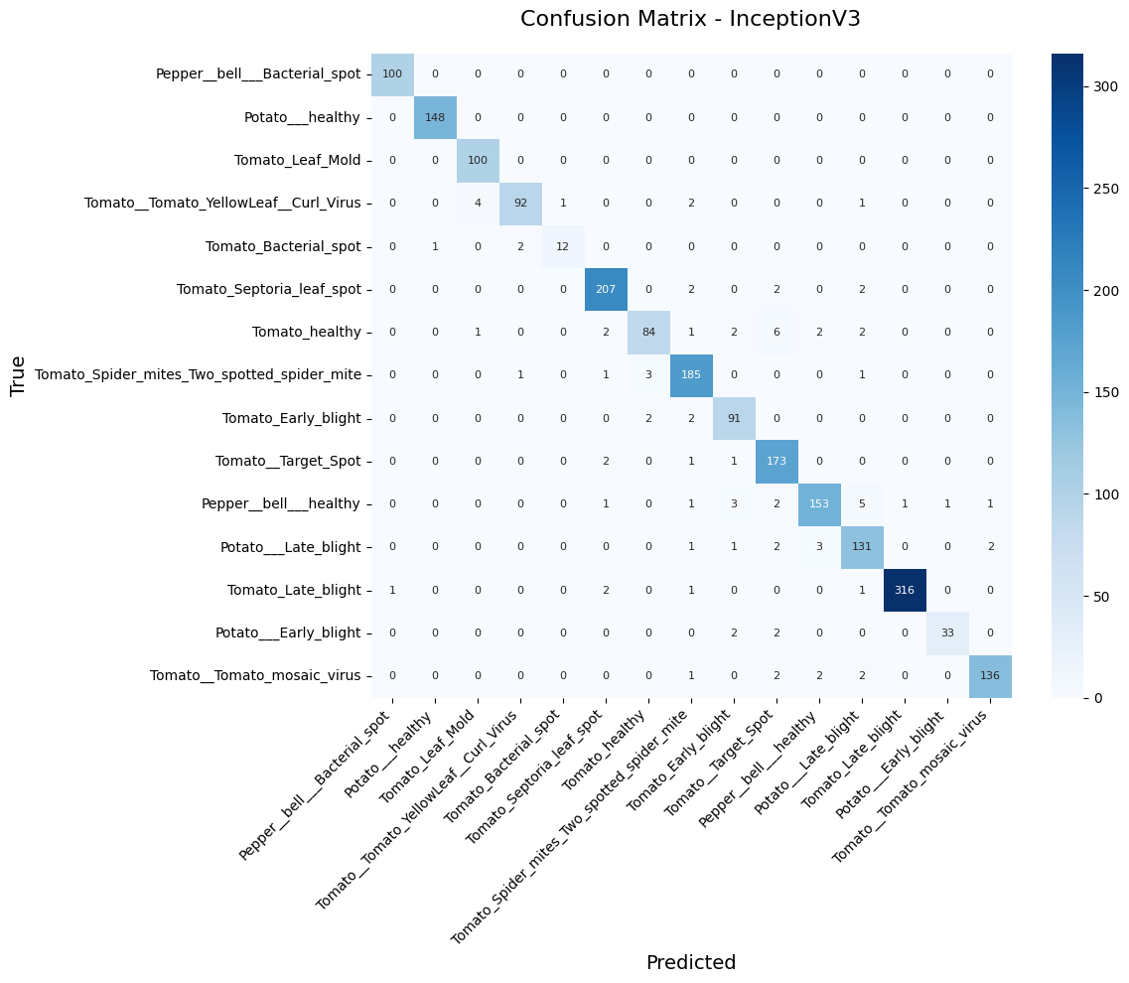
Figure A.10 Confusion Matrix Heatmap for InceptionV3
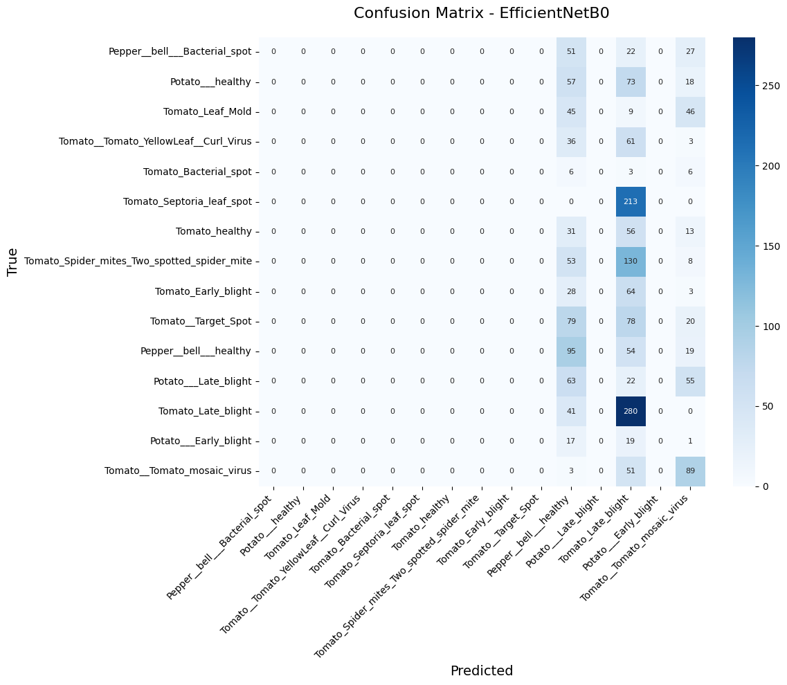
Figure A.11 Confusion Matrix Heatmap for EfficientNetB0
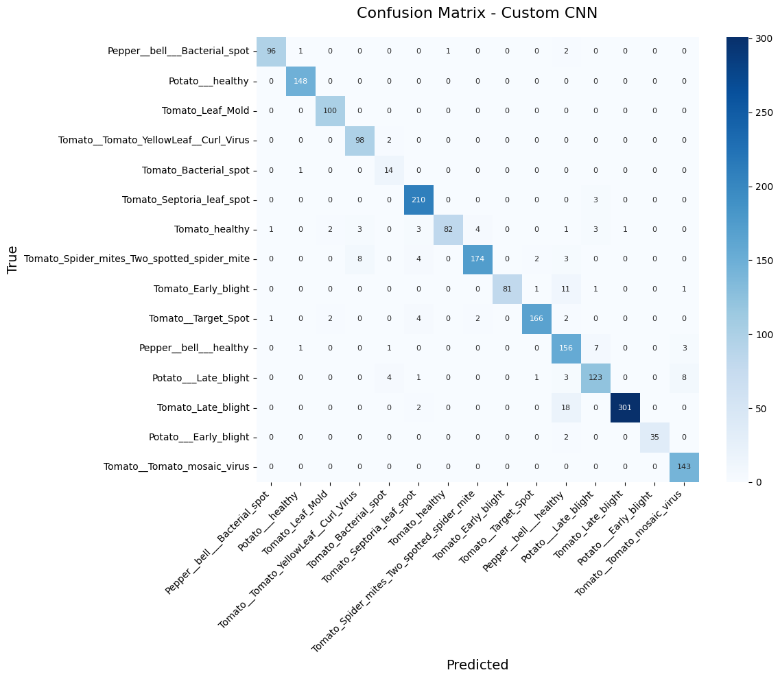
Figure A.12 Confusion Matrix Heatmap for Custom CNN
Glossary:
Accuracy: The proportion of total correct predictions (both true positives and true negatives) out of all predictions.
AlexNet: One of the first convolutional neural network architectures developed for image classification tasks including the usage of ImageNet dataset.
Artificial Intelligence (AI): The capacity of computers or other machines to exhibit or simulate intelligent behavior.
Artificial Neural Network (ANN): Computer technology that attempts to build computers that operate like a human brain.
Convolutional Neural Network (CNN): Type of neural network that is primarily used for analyzing visual data, such as images and videos.
Confusion Matrix: Also known as “Truth Table”; is a tabular data that is used to define the performance of a classification algorithm.
Data Augmentation: a technique used in machine learning to artificially expand the training set by generating new training examples from existing ones.
Deep Learning (DL): A machine learning method that uses hierarchical neural networks
to learn from data in an iterative and adaptive manner.
DenseNet: Short for Densely Connected Convolutional Network; is a feed-forward convolutional neural network (CNN) architecture that links each layer to every other layer.
EfficientNet: a family of scalable object detection models developed by the Google Brain team.
EfficientDet: a family of scalable object detection models developed by the Google Brain team.
F1-Score: harmonic mean of precision & recall, assumes equal cost of confusion matrix components.
Feature Extraction: Technique that reduces the dimensionality or complexity of data to improve the performance and efficiency.
Generative Adversarial Network (GAN): Is a deep learning architecture that is designed to generate realistic data by learning patterns from existing training datasets.
GoogLeNet: Also known as InceptionV1; is a deep convolutional neural network (CNN) developed by researchers at Google for efficient image classification.
Hyperspectral Imaging: Technique involved in data acquisition that collects detailed spectral data for every pixel in an image.
Image Classification: Classifies an image into one of a set of predefined categories.
Image Preprocessing: Set of techniques employed to enhance the quality and extract relevant information from digital images.
Image Segmentation: Process that partitions a digital image into discrete groups of pixels.
K-Nearest Neighbors (KNN): Supervised machine learning algorithm that behaves as a lazy learner where no model is generalized.
Machine Learning (ML): Considered a subfield of artificial intelligence; provides machines with the capability of learning from experiences that comes in the form of data.
MobileNet: Family of convolutional neural networks (CNNs) developed by Google for efficient image classification, object detection, and other computer vision tasks on devices like mobile phones.
Multiclass Classification: A machine and deep learning problem where each input is assigned to one class from three or more possible categories.
Object Detection: A computer vision technique that aims to locate and recognize objects in digital images or videos.
Overfitting: A disadvantageous event where when the trained model is highly fitted to the training data set but performs poorly with regard to testing/external/unseen datasets.
PlantDoc Dataset: Publicly available dataset designed for plant disease classification and detection.
PlantVillage Dataset: Public repository that contains 54,323 images of 14 crops and 38 different types of plant diseases.
Precision: An accuracy of positive predictions.
RGB Image: An image that is represented using the Red, Green, and Blue color channels.
Random Forest (RF): An ensemble learning method for classification, implied as a modification to the simple bagging algorithm
ResNet: A deep learning architecture known for its ability to train very deep neural networks with hundreds or thousands of layers.
Support Vector Machine (SVM): Boundary detection algorithm that achieve a classification or regression decision based on the value of the linear combination of input features.
Test Dataset: The validity of the trained model that is evaluated using a separate test dataset.
Training Dataset: The dataset used to train the model with known attributes (input features) and target labels.
Transfer Learning: A deep learning technique where a model trained on one task is reused as the foundation for a second task.
VGG/VGG16: Short for Visual Geometry Group, is a typical convolutional network architecture used for large scale image recognition. The number 16 refers to the number of learnable layers in the model
YOLO (You Only Look Once): A real time object detection algorithm, known for its speed and accuracy, making it suitable for real time applications.

References:
[3] Singh, P. P., Kanth, D. R., Madhuri, G. S., Yadav, A., Chauhan, S. S., Kundu, P., Bhattacharyya, U. K., Banoo, S., Ritu, & Rajput, U. S. (2025). Deep Learning Techniques for Plant Disease Detection and Classification: A Comprehensive Review. International Journal of Advanced Biochemistry Research, SP 9(1), 187–200. https://doi.org/10.33545/26174693.2025.v9.i1Sc.3457
[1] Das, P., Adhikary, D. N., & Sen, P. (2022). Automated Detection of Plant Diseases A Promising Tool for Smart Agriculture. Asian Journal of Biological and Life Sciences, 11(3), 656–661. https://doi.org/10.5530/ajbls.2022.11.87
[4] Bhagwat, R., & Dandawate, Y. (2021). A Review on Advances in Automated Plant Disease Detection. International Journal of Engineering and Technology Innovation, 11(4), 251–264. https://doi.org/10.46604/ijeti.2021.8244
[7] Mohanty, S. P., Hughes, D. P., & Salathé, M. (2016). Using Deep Learning for Image Based Plant Disease Detection. Frontiers in Plant Science, 7, 1419. https://doi.org/10.3389/fpls.2016.01419
[9] Andrew, J., Eunice, J., Popescu, D. E., Chowdary, M. K., & Hemanth, J. (2022). Deep Learning Based Leaf Disease Detection in Crops Using Images for Agricultural Applications. Agronomy, 12(10), 2395. https://doi.org/10.3390/agronomy12102395
[2] Mustofa, S., Munna, M. M. H., Emon, Y. R., Rabbany, G., & Ahad, M. T. (2023). A Comprehensive Review on Plant Leaf Disease Detection Using Deep Learning.
[6] Abade, A. S., Ferreira, P. A., & Vidal, F. B. (2020). Plant Diseases Recognition on Images Using Convolutional Neural Networks: A Systematic Review. [Preprint]. arXiv:2009.04365
[5] Kamilaris, A., & Prenafeta Boldú, F. X. (2018). Deep Learning in Agriculture: A Survey. Computers and Electronics in Agriculture, 147, 70–90. https://doi.org/10.1016/j.compag.2018.02.016
[8] Balafas, V., Karantoumanis, E., Louta, M., & Ploskas, N. (2023). Machine Learning and Deep Learning for Plant Disease Classification and Detection. IEEE Access, 11, 114352–114367. https://doi.org/10.1109/ACCESS.2023.3324722
[10] Yao, J., Tran, S. N., Sawyer, S., & Garg, S. (2023). Machine Learning for Leaf Disease Classification: Data, Techniques and Applications. arXiv preprint arXiv:2310.12509. https://arxiv.org/abs/2310.12509
[11] Ferentinos, K. P. (2018). Deep learning models for plant disease detection and diagnosis. Computers and Electronics in Agriculture, 145, 311–318. https://doi.org/10.1016/j.compag.2018.01.009

